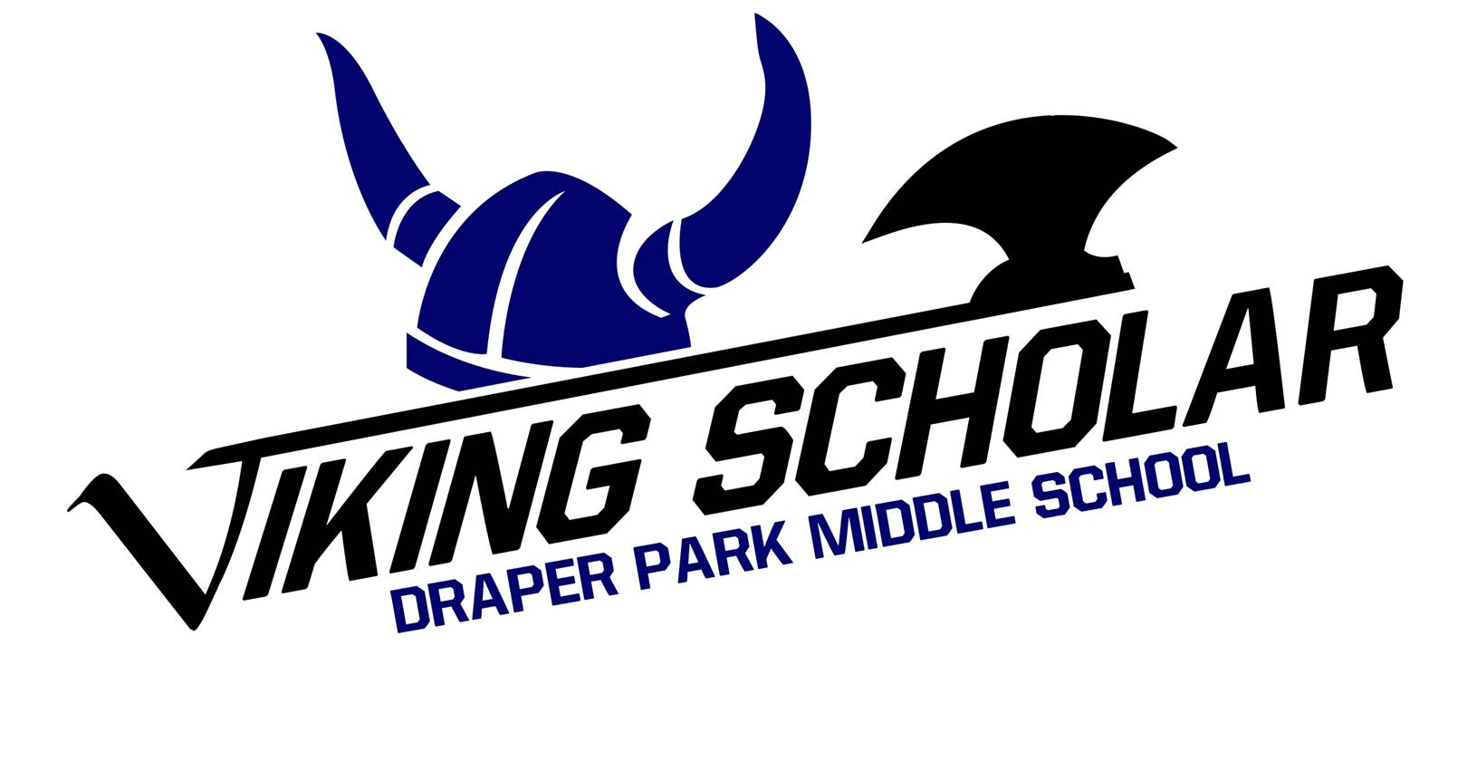
Draper Park Middle School Viking Scholar Application Timeline

Step 1: Complete application at http://draperpark.canyonsdistrict.org/viking-scholar.html
You will need your Canyons School District CSD Docs log-in information in order to access the application.
For this step you will need to know the following:
- Your Canyons School District student ID number (your lunch number)
- Which 2 subject categories you wish to apply for
- Your grade point average (GPA)
- Your citizenship grades
- A list of awards, certificates, recognition you have received in your academic career, but preferably in middle school
- Information about leadership roles you have held at school or in the community
- Why you want to apply for Viking Scholar, written in a one-page, five-paragraph essay
Application Opens: December 16, 2019, 7:00am.
Application Deadline: January 13, 2020, 3:00pm.

Step 2: Begin building your portfolio by collecting artifacts that demonstrate your skill, interest,
personality, and achievement in the categories you have applied in.

Portfolios should demonstrate a variety of abilities and knowledge in the subject area. For example, in Language Arts, the portfolio should include many written pieces from different genres.

In some categories, such as performing arts and theatre, candidates will be asked to perform a scene from a play or musical, sing a song, or play an instrument in order to demonstrate your proficiency, so this is a good time to start preparing that selection.
Portfolio Deadline: February 27, 2020, Student Center, 3:00pm.

Step 3: If you are selected for the next round, you will be asked to schedule a time when you
can interview with a panel of your teachers, and, if applying in performing arts, perform a selection that demonstrates your skill in that category.
The interviews and performances will be scheduled during the week of March 23, 2020, with most interviews taking place between 7:00AM – 9:00AM on March 27.

Step 4: Using the interviews and performances, portfolios, GPA, citizenship, and leadership
information, candidates will be evaluated and a winner will be chosen.
The Viking Scholar banquet is tentatively scheduled for May 7, 2020.

For additional information or help with any of these steps, please contact your teacher in the subject area in which you are applying, or Mr. Seltz in the main office.

